Special Ladybug

Equipment:  2 empty yogurt cups  1 pink lady apple box  Black paint  Red paint  Paint brush  1 shoe box  1 empty cereal box  Tape  Scissors | 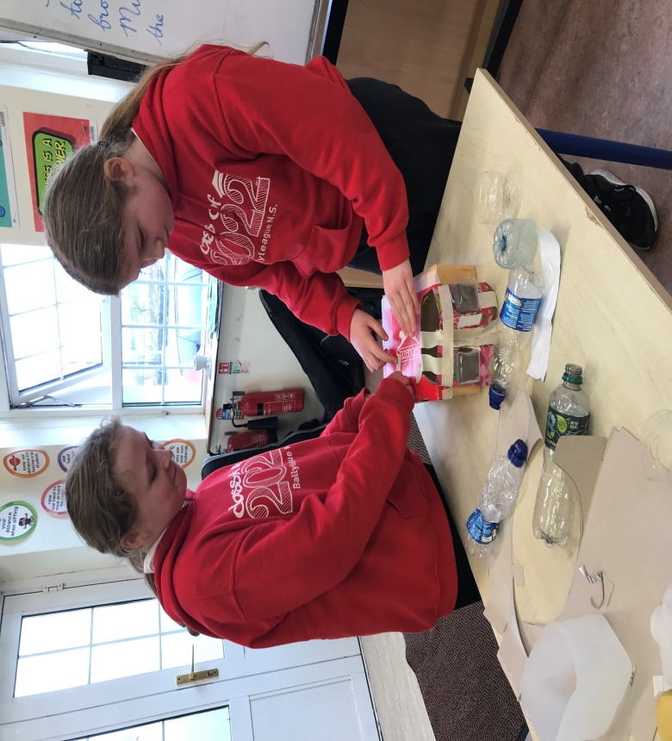

Method:
Step 1- Push the two empty yogurt cups through the two holes in the pink lady apple box to make the eyes and head.
Step 2- Cut a couple circles out of the empty cereal box.
Step 3- Cut the lid of the shoe box. Flip it around and place a line of tape to separate the back.
Step 4- Paint the ladybug. (Shoe box-red, circles-black, yogurt cups-black, pink lady apple box-red and the line in the middle of the box-black.)
Step 5- Tape the head and spots to the shoe box.

